**NEXUS**

**Sonatype Nexus**

* Nexus is an Open Source Software
* It is an **Artifact Repository Server**
* It is used to **store and retrieve build artifacts**
* We can **store shared liabraries** also (e.g pwd-utils.jar) (company specific remote)
* **Nexus** software developed using **Java**
* Note: To install Nexus s/w we need to install java first
* Currently people are using **Nexus 3.x**

Java: jar, war and ear

Docker : Docker images

Node JS: NPM package

Q) What is difference between Nexus and GitHub ?

Github is Source code management software which is used to **store source code** of the project

Nexus is **Artifact Repository** which is used to **store build artifacts**

**Nexus Setup**

Take t2.medium instance

Java s/w is required to install Nexus

Connect to t2.medium instance using mobaxterm

Nexus S/w Installation Process in Linux OS

* **$ sudo su -**
* **$ cd /opt**
* **$ yum install tar wget -y**

Note: https://help.sonatype.com/repomanager3/product-information/download

Latest version

* **$ wget https://download.sonatype.com/nexus/3/nexus-3.40.1-01-unix.tar.gz**

Old version

* **$ wget http://download.sonatype.com/nexus/3/nexus-3.15.2-01-unix.tar.gz**
* **$ tar -zxvf nexus-3.40.1-01-unix.tar.gz**
* **$ mv /opt/nexus-3.40.1-01 /opt/nexus**

As a good security practice, Nexus is not advised to run nexus service as a root user, so create a new user called nexus and grant sudo access to manage nexus services as follows.

* **$ useradd nexus**

Give the sudo access to nexus user

* **$ visudo**
* **nexus ALL=(ALL) NOPASSWD: ALL**

Change the owner and group permissions to /opt/nexus and /opt/sonatype-work directories.

* **$ chown -R nexus:nexus /opt/nexus**
* **$ chown -R nexus:nexus /opt/sonatype-work**
* **$ chmod -R 775 /opt/nexus**
* **$ chmod -R 775 /opt/sonatype-work**

Open /opt/nexus/bin/nexus.rc file and uncomment run_as_user parameter and set as nexus user.

* **$ vi /opt/nexus/bin/nexus.rc**
* **run_as_user="nexus"**

Create nexus as a service

* **$ ln -s /opt/nexus/bin/nexus /etc/init.d/nexus**

Install java 1.8v

* **$ sudo yum install java-1.8.0-openjdk**

Switch as a nexus user and start the nexus service as follows.

* **$ su - nexus**

Enable the nexus services

* **$ sudo systemctl enable nexus**

Start the nexus service

* **$ sudo systemctl start nexus**

Access the Nexus server from Laptop/Desktop browser.

URL: http://IPAddess:8081/

**Note:** Enable this 8081 port number in Security Group

Default Username

User Name: admin

We can copy nexus password using below command

* **$ sudo cat /opt/sonatype-work/nexus3/admin.password**

We can change nexus default properties

* **/opt/nexus/etc/nexus.properties**

**Integrate Maven with Nexus**

Create Repositories in Nexus to store build artifacts

We will create 2 types of repositories in Nexus

1) **Snapshot**

**2) Release**

If project is **under development** then that project build artifacts will be stored into **snapshot repository**

If project **development completed** and released to production then that project build artifacts will be stored to **release repository**

Snanpshot Repo URL: http://13.233.238.64:8081/repository/ashokit_snapshot_repo/

Release Repo URL: http://13.233.238.64:8081/repository/ashokit_release_repo/

Note: Based on <version/> name available in project pom.xml file it will decide artifacts should be stored to which repository

Nexus Repository details we will configure in project pom.xml file like below

**<distributionManagement>**

**<repository>**

<id>nexus</id>

<name>Ashok IT Releases Nexus Repo</name>

<url>http://15.207.19.102:8081/repository/ashokit-release-repository/</url>

**</repository>**

**<snapshotRepository>**

<id>nexus</id>

<name>Ashok IT Snapshots Nexus Repo</name>

<url>http://15.207.19.102:8081/repository/ashokit-snapshot-repository/</url>

**</snapshotRepository>**

**</distributionManagement>**

Nexus Server Credentials will be configured in Maven **"settings.xml"** file.

Maven Location: **C:\apache-maven-3.8.5\conf**

In settings.xml file, under <servers> tag add below <server> tag

<server>

<id>nexus</id>

<username>admin</username>

<password>admin@123</username>

</server>

Once these details are configured then we can run below maven goal to upload build artifacts to Nexus Server

**$ mvn clean deploy**

**Remote Repository**

Remote repository used for **shared libraries**

If we want to use **few jar files in multiple projects** in the company then we will **use Remote Repository**

**Remote repository is specific to our company projects**

Create remote repo in nexus and upload a jar file

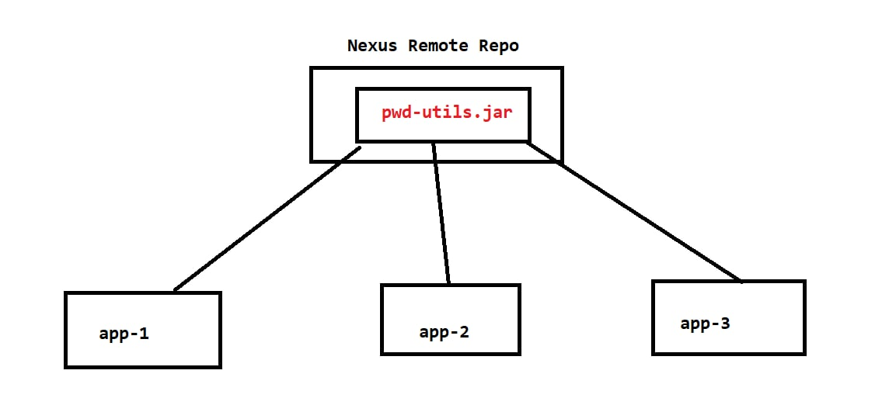

Take dependency details of uploaded jar file and add in project pom.xml as a dependency

We need to add Remote Repository Details in pom.xml above <dependencies/> tag

<repositories>

<repository>

<id>nexus</id>

<url>repo-url</url>

</repository>

</repositories>

After adding the remote repository details do maven package and see dependency is downloading from nexus repo or not.

**We will create users and will give access for users for our repositories**